CN Railroad Scholarships

CN is pleased to announce the availability of two scholarships for Michigan Tech students with interests in the railroad industry.

Amount of Award: Each scholarship awarded will be in the amount of $1,000.

Eligibility: Applicants for the CN Railroad Scholarships must be an undergraduate student at Michigan Tech University in good standing and interested in the railroad industry. Open to all disciplines.

Application Process: To apply for CN Railroad scholarships the materials listed below must be submitted to David Nelson, 301 Dillman Hall, Michigan Tech University, phone: (906) 487-2568 by Friday, December 8th, 2017 by email: dannelso@mtu.edu Please also visit https://goo.gl/e7dcPY for more information.

Application package must include:
- A personal statement, not to exceed 350 words, explaining why the applicant believes he/she is deserving of an CN Railroad Scholarship. The applicant should indicate areas of railroading which might be of particular interest and describe how his/her attributes relate to these areas.
- A history of recent work experience, not to exceed 350 words
- Current GPA
- Contact information for two references that may be contacted by the scholarship committee
- Photo/headshot of applicant
- Copy of School Transcript (can be unofficial)

Successful applicants will be informed of awards by the early part of the spring 2018 semester.
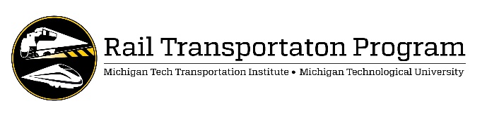
Name:
Last First Middle Initial
Address:
Street/PO Box City State Zip

Telephone: E-Mail:
Level of Study: ☐ Graduate ☐ Undergraduate

Major Academic Concentration:

Hours/Credits Completed

Overall GPA:

Anticipated Graduation Date: Degree:

Personal Statement Positions (350 Words Max):

Work History and Experience (350 Words Max):

Recommendations – List at least 2 References below:

Name | E-mail | Phone

I have attached the following:

- Photo/headshot
- Copy of Transcript

Signature: Date:
Submit this form with required materials digitally to David Nelson, dannelso@mtu.edu, Department of Civil and Environmental Engineering, Michigan Technological University, by Friday, December 8th, 2017.

